# **Configure a Custom Domain**

In this exercise, you will configure a custom domain for your Web App. This requires that you own a custom domain that you can point to your Web App.

## **Task 1: Validate the Root Domain**

In this task, you’ll validate your root domain (yourdomain.com) so that you’ll know what DNS records you need to add in the next task.

1. Open your Web App in the Azure portal and click **Custom Domains** in the menu.
2. Click **Add Hostname**.

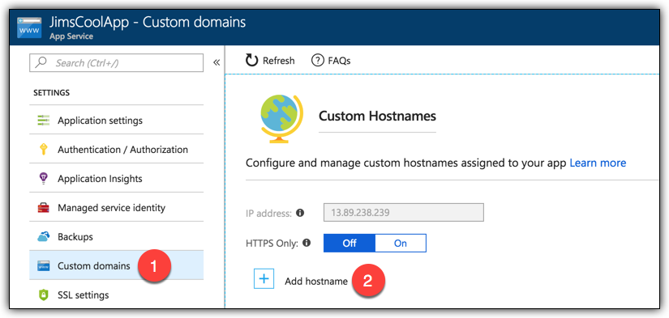

1. Enter the root domain for your domain.
2. Click **Validate**.

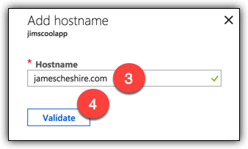

App Service will check the DNS settings for your domain. It will tell you which DNS records you need to add in order for you to successfully add the hostname to your Web App.

When adding a root domain, you need to configure an A-record and a TXT record as shown in the figure below. You’ll add these DNS records in the next task. (Note that your values may differ from what you see below.)

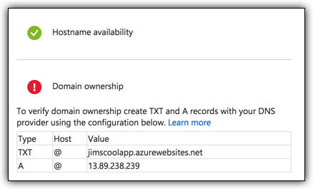

## **Task 2: Add DNS Records for the Root Domain**

DNS configuration differs between domain registrars. In this task, I’ll show screenshots of configuring DNS records at GoDaddy. If your domain is not registered with GoDaddy, the steps will look different for you, but the records to configure will be the same.

1. Log into your domain registrar’s website.
2. Go to your registrar’s interface for managing your DNS records. At GoDaddy, click the **DNS** button next to your domain.

Your registrar should already have an A-record configured for your domain. It will point to an IP address assigned by your domain registrar. You will need to edit this A-record so that it points to the IP address shown in the Azure portal.

1. Edit the IP address for the A-record and enter the IP address shown in the Azure portal.
2. Save your changes.

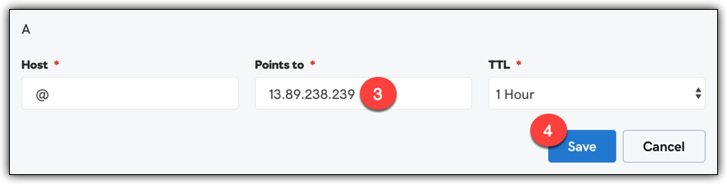

Note that GoDaddy configure the A-record host as **@**. This is shorthand for the domain you’re configuring.

Next, you’ll need to add a TXT-record. Azure uses the TXT-record to verify that you actually own the domain you’re adding in the portal. The TXT-record value should be the azurewebsites.net URL for your Web App as shown in the Azure portal.

Most domain registrars will not already have a TXT-record configured, so you’ll need to add it.

1. Add a new record in your DNS settings. (At GoDaddy, there’s an **Add** link at the bottom of your DNS records.)
2. Set the record type as **TXT**.
3. Use **@** for the host. If your registrar won’t allow that, use the root domain (yourdomain.com.)
4. Set the value to the azurewebites.net URL shown in the Azure portal.
5. Save your changes.

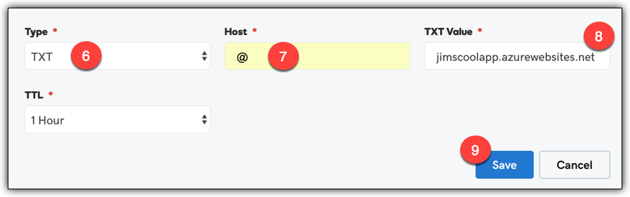

## **Task 3: Validate the Hostname Again**

Now that you’ve added the necessary records, you can validate your hostname again. Keep in mind that DNS propagations can sometimes take a little while, but they usually only take a minute or so. If validation still fails, wait a few minutes and try again.

1. If you closed the Add Hostname blade in the Azure portal, complete the steps in Task 1 again to re-validate your domain.
2. If the Add Hostname blade is still open, click **Validate** to re-validate your domain.

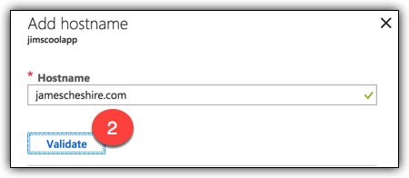

1. Ensure that both Hostname Availability and Domain Ownership show a green check.
2. Click **Add Hostname** to add your hostname.

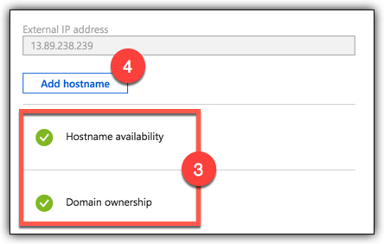

You should see your root domain in the list of hostnames under Hostnames Assigned to Site in the Custom Domains blade in the portal. You can now browse to your root domain to access your Web App.

## **Task 4: Validate the www Subdomain**

We also want to be able to browse to our Web App using the www subdomain. Let’s see what we need to do to add the www subdomain.

1. In the Custom Domains blade, click **Add Hostname**.
2. Enter the www subdomain for your domain.
3. Click **Validate**.

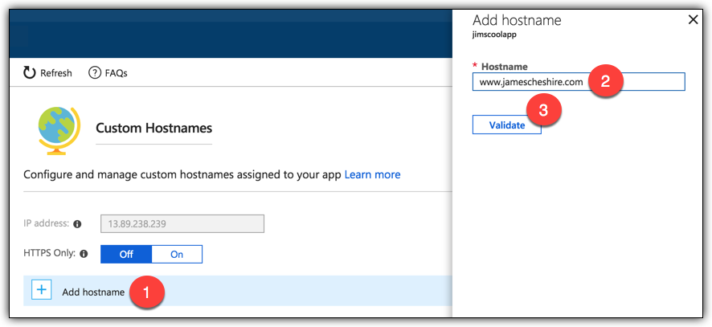

App Service will check the DNS settings for the www subdomain. It will then tell you what record(s) you need to add in order to add that hostname. As you can see in the figure below, I need to add a CNAME-record that maps the www subdomain to my azurewebsites.net URL.

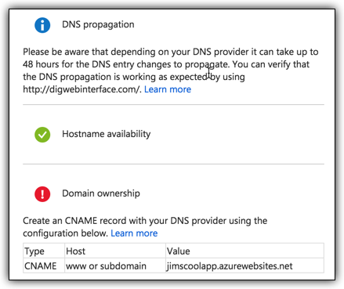

## **Task 5: Add DNS Record for the Subdomain**

I need to add a CNAME that points “www” to my azurewebsites.net URL.

1. Add a new record at your domain registrar.
2. Set the record type to **CNAME**.
3. Set the host to **www**.
4. Set the value to your azurewebsites.net URL.
5. Save your changes.

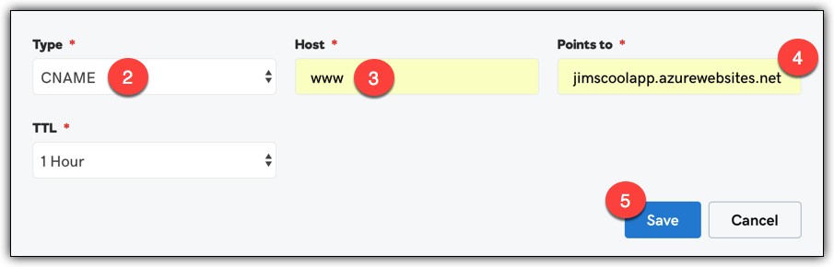

1. Wait for a few minutes and then validate the subdomain again.

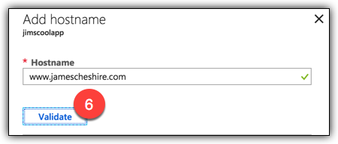

1. Ensure that Domain Ownership now shows a green check.
2. Click **Add Hostname** to add the entry for the www subdomain.

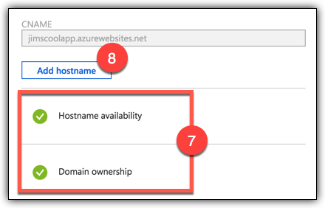

You can now browse to your Web App using either *yourdomain.com* or using *www.yourdomain.com*.